

Table of Contents

Introduction 1

References 3

Course Contents 3

GitHub List Commits 3

What Even Is Webpack 3

Installing and Running Webpack and Webpack-CLI 5

Install Webpack 7

Webpack Default Configuration 9

Imports, Exports, & Webpack Modules 12

Configuring Webpack 13

Loaders, CSS, & SASS 17

# Introduction

**Webpack** is a powerful tool used in web development. Let’s dive into what it does:

1. **Module Bundler**:
   * **Webpack** is primarily a **module bundler**.
   * Its main purpose is to bundle JavaScript files (and other assets) for usage in a web browser.
   * Imagine it as a way to package all your code and assets into a single file or a few files that the browser can efficiently load.
   * It takes your project’s various modules (JavaScript files, CSS, images, etc.) and combines them into a single output file (or multiple files) that can be served to the browser.
2. **JavaScript Transformation and Optimization**:
   * Besides bundling, **Webpack** can also perform transformations on your code.
   * It can transpile modern JavaScript (ES6+) into older versions (ES5) using tools like Babel.
   * It optimizes your code by minifying it (removing unnecessary whitespace and renaming variables) to reduce file size.
   * This results in faster loading times for your web application.
3. **Configuration-Driven**:
   * **Webpack** uses a configuration file called webpack.config.js.
   * In this file, you define how your project should be bundled.
   * You specify entry points (where the bundling process starts), output paths, loaders (for handling different file types), and plugins (for additional tasks like code splitting or generating HTML files).
4. **Loaders and Plugins**:
   * **Loaders** allow **Webpack** to process different types of files (e.g., CSS, images, fonts) and convert them into valid modules.
   * **Plugins** enhance the bundling process by performing additional tasks.
   * For example, the **HTMLWebpackPlugin** generates an HTML file with the bundled JavaScript automatically injected.
5. **Code Splitting**:
   * **Webpack** supports code splitting, which means breaking your bundle into smaller chunks.
   * This is useful for optimizing performance by loading only the necessary parts of your application when needed (e.g., lazy loading routes).
6. **Development and Production Modes**:
   * **Webpack** has different modes: **development** and **production**.
   * In development mode, it provides features like source maps for easier debugging.
   * In production mode, it aggressively optimizes your code for better performance.
7. **Community and Documentation**:
   * The **Webpack** community is active, and there are plenty of plugins and loaders available.
   * The official documentation is comprehensive and provides guides, concepts, and examples to get you started.

In summary, **Webpack** is a versatile tool that simplifies managing your project’s assets, optimizes your code, and makes web development more efficient. If you’re new to it, check out the [Getting Started guide](https://webpack.js.org/guides/getting-started/) to explore its features!

# References

[Learn Webpack - Full Tutorial for Beginners](https://www.youtube.com/watch?v=MpGLUVbqoYQ&list=WL&index=3&t=2341s)

[Colt Steele's YouTube channel](https://www.youtube.com/channel/UCrqAGUPPMOdo0jfQ6grikZw)

[Colt Steele Github Code](https://github.com/Colt/webpack-demo-app)

Course Contents

⌨️ (0:00:00) What Even Is Webpack??

⌨️ (0:08:12) Installing and Running Webpack and Webpack-CLI

⌨️ (0:22:18) Imports, Exports, & Webpack Modules

⌨️ (0:29:58) Configuring Webpack

⌨️ (0:38:57) Loaders, CSS, & SASS

⌨️ (0:53:55) Cache Busting and Plugins

⌨️ (1:07:13) Splitting Dev & Production

⌨️ (1:17:13) Html-loader, File-loader, & Clean-webpack

⌨️ (1:28:17) Multiple Entrypoints & Vendor.js

⌨️ (1:34:45) Extract CSS & Minify HTML/CSS/JS

# GitHub List Commits

1. [Initial app code, no webpack](https://github.com/johncusey/webpack-demo-app/commit/b96a9dbce0d4abbf156612ccb23e4be74d6fd313) (What Even Is Webpack??)
2. [Break code into separate scripts, no webpack](https://github.com/johncusey/webpack-demo-app/commit/dd5492493336955c66c8960d4e50d76297199fbb) , [Installed webpack](https://github.com/johncusey/webpack-demo-app/commit/2400d188ea69f4a3bc6dd0f35e58f81dd8135e35) (Installing and Running Webpack and Webpack-CLI)
3. [Webpack now bundling all our app code](https://github.com/johncusey/webpack-demo-app/commit/2b11dd3624422ac8f57fced592dd824230c83693) (Imports, Exports, & Webpack Modules)
4. [Add webpack config file](https://github.com/johncusey/webpack-demo-app/commit/d13f75ab6c6c90e1e7232c2b03fde96b0dd8e6a5) (Configuring Webpack)
5. [Add first loaders to handle css](https://github.com/johncusey/webpack-demo-app/commit/65c2ac47091e301b3adc5b35a68c1870b16eafb7) (Loaders, CSS, & SASS)

# What Even Is Webpack

Webpack Official Website:

Webpack Official GitHub Website:

The file structure webpack generates.

Command for building a React Application.

The file structure Webpack generates

# Installing and Running Webpack and Webpack-CLI

Example code base used by Colt Steele

The file structure of the starter project.

Screen shot the the appliction

The coding structure after refactoring the code into many files for Webpack to bundle.

You have to include all the JavaScript files in script tags. If you use Webpack you can eliminate all these script tags.

## Install Webpack

1) Install Package Json

Install package json file run the following command. The package.json file is a crucial part of Node.js projects. Here’s what it does:

1. **Metadata and Descriptive Information**:
   * It’s a **JSON file** residing in the root directory of your project.
   * Contains both **human-readable metadata** (like project name and description) and **functional metadata** (such as package version number).
   * Helps people discover your package by providing a **description** and **keywords**.
   * [Specifies the **project homepage URL** and the **issue tracker URL** where users can report issues1](https://docs.npmjs.com/cli/v6/configuring-npm/package-json/)[2](https://heynode.com/tutorial/what-packagejson/).
2. **Dependency Management**:
   * Lists the **dependencies** required by your application.
   * When you run npm install, it installs the dependencies specified in this file.
   * Helps manage versions and ensures consistent behavior across different environments.
3. **Versioning**:
   * The **name** and **version** fields together form a unique identifier for your package.
   * Changes to the package should correspond to changes in the version.
   * If you plan to publish your package, these fields are **required**.
   * [If not publishing, they are **optional**1](https://docs.npmjs.com/cli/v6/configuring-npm/package-json/).
4. **License Information**:
   * Specify a **license** for your package (e.g., BSD-3-Clause or MIT).
   * Helps users understand how they can use your package.
   * [Use SPDX license identifiers or custom strings1](https://docs.npmjs.com/cli/v6/configuring-npm/package-json/).
5. **Scripts and Commands**:
   * Define custom **scripts** (e.g., build, test, start) that can be executed using npm run.
   * Makes it easy to automate common tasks during development.
6. **Other Details**:
   * You can include a **file** named <filename> at the top level of the package.
   * [Deprecated styles like license objects are now replaced with SPDX expressions1](https://docs.npmjs.com/cli/v6/configuring-npm/package-json/)[3](https://nodesource.com/blog/the-basics-of-package-json/).

In summary, package.json is your project’s **manifest**, containing essential information for Node.js, npm, and JavaScript development.

**$ npm init -y**

2) Install Webpack and Webpack CLI



**npm install --save-dev webpack webpack-cli**

3) Changing script in Package Json

# Webpack Default Configuration

Have Webpack bundle the project by using the script in the Package Json. The **“scripts”** property allows you to define custom commands that can be executed.



If you see the following error you need ***index.js*** file in the ***src folder***.



Solution:

After run Webpack you get the following message. The ***index.js*** is the entry point

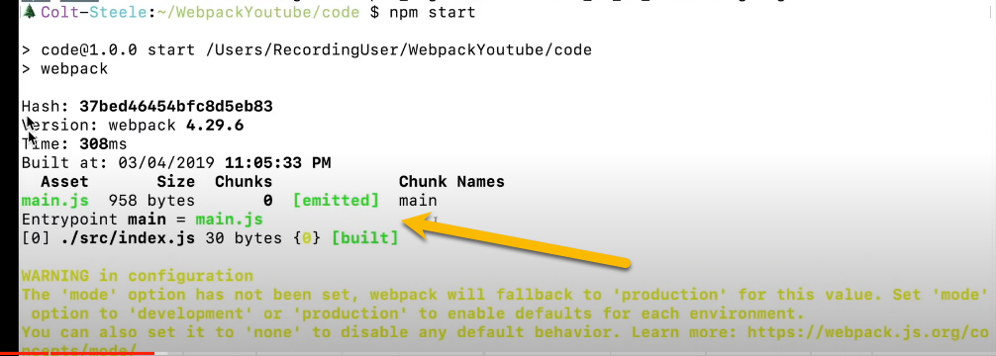

Webpack create the **dist** folder with ***main.js***

You need to added ***main.js*** to your ***index.html*** file.

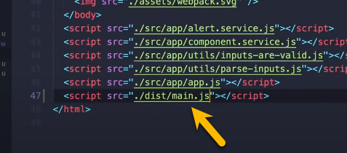

Now you can see calling the ***index.js*** entry point file.

We are going to put all our ***JavaScript code*** in the ***Index.js*** file.

# Imports, Exports, & Webpack Modules

All the files you have to add export and import:

Most important in your ***index.js*** which is your entry point to your application most put the run function.

In the index.html you need just the entry point file which is located in the dist folder.

Now you have to start Webpack:



# Configuring Webpack

**Webpack** is a powerful build tool that helps bundle and optimize your JavaScript, CSS, and other assets for web applications. It allows you to manage dependencies, transpile code, and create production-ready bundles. Let’s dive into some key points about configuring Webpack:

1. **Out-of-the-Box Defaults**:
   * By default, Webpack assumes that your project’s entry point is src/index.js and generates a minified and optimized bundle in dist/main.js for production.
   * You don’t need a configuration file initially, but most projects eventually require customizations.
2. **Creating a Configuration File**:
   * To extend Webpack’s functionality, create a webpack.config.js file in your project’s root folder.
   * This configuration file allows you to specify various options and features.
   * You can find all available configuration options in the [official documentation](https://webpack.js.org/configuration/).
3. **Customizing Your Configuration**:
   * If you want to use a different configuration file based on specific situations, you can specify it via the command line using the --config flag.
   * For example, in your package.json:

**JSON**

"scripts": {

"build": "webpack --config prod.config.js"

}

* + To set up a new Webpack project, consider using webpack-cli’s init command:

***npx webpack init***

* + This command will guide you through creating a configuration file based on your project requirements.

1. **Webpack Config Basics**:
   * A Webpack config is a JavaScript object that configures various options.
   * You can define loaders, plugins, entry points, output paths, and more.
   * Most projects use a top-level webpack.config.js file, but you can also pass the config as a parameter to Webpack’s Node.js API.

Remember that Webpack’s configuration can be overwhelming due to its extensive options, but tools like webpack-cli can simplify the process. Explore the [Getting Started guide](https://webpack.js.org/guides/getting-started/) to learn more!

**Webpack Config Basics**:

* A Webpack config is a JavaScript object that configures various options.
* Common options include:
  + entry: Specifies the entry point(s) for your application.
  + output: Defines where Webpack should put the bundled files.
  + loaders: Handles different file types (e.g., transpiling JavaScript with Babel).
  + plugins: Enhances Webpack’s functionality (e.g., minification, code splitting).

[Webpack Configuration Definations](https://webpack.js.org/configuration/)

The webpack.config.js file plays a crucial role in configuring **Webpack**, allowing you to customize its behavior according to your project’s needs. [You’ll typically find this file in the root folder of your project, alongside the package.json file1](https://webpack.js.org/configuration/)[2](https://desarrolloweb.com/articulos/configuracion-webpack-config-js.html).

Here are some key points about the webpack.config.js file:

1. [Default Behavior: By default, Webpack assumes that your project’s entry point is src/index.js and generates the output in dist/main.js, which is minified and optimized for production1](https://webpack.js.org/configuration/).
2. **Creating Your Own Configuration**: To extend Webpack’s functionality, you can create a webpack.config.js file in your project’s root folder. Webpack will automatically use it when building your project. [All available configuration options are specified in this file1](https://webpack.js.org/configuration/).
3. **Example Initialization**:
   1. To quickly generate a Webpack configuration, you can use the following command:
   2. npx webpack init
   3. This command will prompt you to install @webpack-cli/generators if it’s not already installed. It will also ask you a series of questions to tailor the configuration to your needs. For example:
      1. Which JavaScript solution do you want to use? (ES6)
      2. Do you want to use webpack-dev-server? (Yes)
      3. Do you want to simplify HTML file creation for your bundle? (Yes)
      4. Do you want to add PWA support? (No)
      5. Which CSS solution do you want to use? (CSS only)
      6. Will you be using PostCSS in your project? (Yes)
      7. Do you want to extract CSS only for production? (Yes)
      8. Do you want to install prettier for formatting the generated configuration? (Yes)
      9. [Pick a package manager (e.g., pnpm)](https://webpack.js.org/configuration/)[1](https://webpack.js.org/configuration/).
4. [**Remember**: Webpack applies configuration defaults after plugin defaults, so you can fine-tune your setup as needed1](https://webpack.js.org/configuration/).

Feel free to explore the available options and features in your webpack.config.js file to optimize your Webpack build process! 😊

**Important !** Tell Webpack which file to uses. You can set the value in your package.json file.

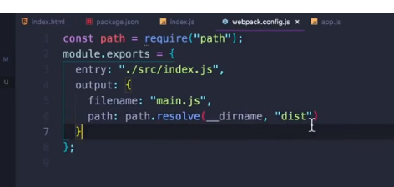

In the webpack.config.js setting the devtool property to get rid of the eval in JavaScript code the bundle files.

You can see that your code is in the Webpack bundle files unchanged.

# Loaders, CSS, & SASS